BASIC NETWORKING -------
**** Wi-Fi range, examples of hosts and nodes, how to connect multiple roters to modem,cloud computing.

Chapter 1 (video 1)
This chapter covers very small details about networking, about the basic terms, basic understanding. Each will be discussed elaborately later.
Keywords-router, switch, firewall, client, server, could (internet), LAN.

Networking is the connection between devices such as computer, laptop, mobile, switches, hub, internet (cloud), and servers in order to communicate among then to send or receive data. It’s known as digital communication.
- The devices connected with each other are known as nodes.
- The differences between host and nodes are, host must have a unique ip address. In other words, all the hosts are nodes but all nodes are not host if they don’t require an ip address.
- The differences between a router and a switch are, switch are used to connect devices inside internal network (LAN) which means the computers or devices connected to each other can send or receive data with each other without an internet connection. However, router routes over the internet which means it connects multiple LAN connections in order to send/receive data over different geographical locations. Switch has more ports than router. Router has both WAN and LAN ports (LAN ports are the Ethernet ports).
- The differences between hub and switch, basically hub and switches are both same, hub has exactly the same functionality as switches, but it differs how it communicates or transfer data over the devices. Switch is smarter than hubs, hub sends data all over the network which means it transfer data to every devices connected to it even if it was not intended for other devices while switch stores the mac address of the devices connected and only sends data to the specific device where it is needed to be sent.
- The differences between modem and router are, modem is the device connected to the internet service provider. It cannot connect multiple devices of a network. Only one Ethernet cable can connect to a single device. However, router is connected to both modem and multiple devices. However nowadays the modem and router can be integrated.
- LAN-Local Area Network- office network same building.
MAN-Metropolitan Area Network- different branch in same city.
WAN – Wide Area Network – All over the country/world (NO geographical restriction)- Internet.
- Client – A client can be any device (laptop, mobile, computer, printer anything) which sends request to server (another laptop, computer, mobile, server-cloud) for data.
- Server- A server is who serves the client with data.
** Server and Client are endpoints. Endpoints are the final destination of data senders or receivers.
- Firewalls- Firewalls are the protection from attacks. A firewall can be a hardware or a host-based one.
- Cloud Networking – Every organization must store all the resources somewhere so that when needed can be accessed. Now this resources can a house or building with servers to store them as private or buy virtual cloud (machine) from other provider to store the data which can be accessed remotely.

Chapter 2 (Video 3)
This Chapter explains the detailed understanding of Ethernet cable, types of wire, bits, bytes, internet speeds etc.

Keywords: RJ port, Ethernet, Network Protocols, Industry standard (physical/logical), Bit, Byte, Speed, Kilobit, Megabit, Gigabit, Terabit, UTP, Full duplex, Straight Through Cable, Cross over cable, Auto MDI x.

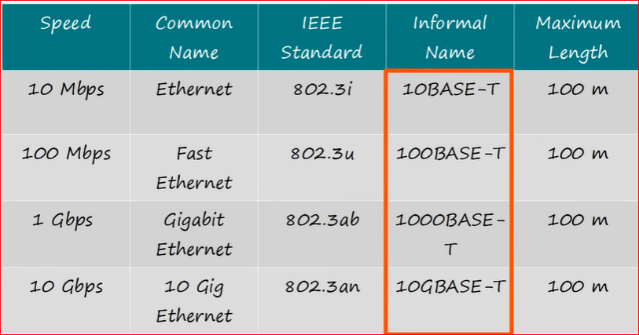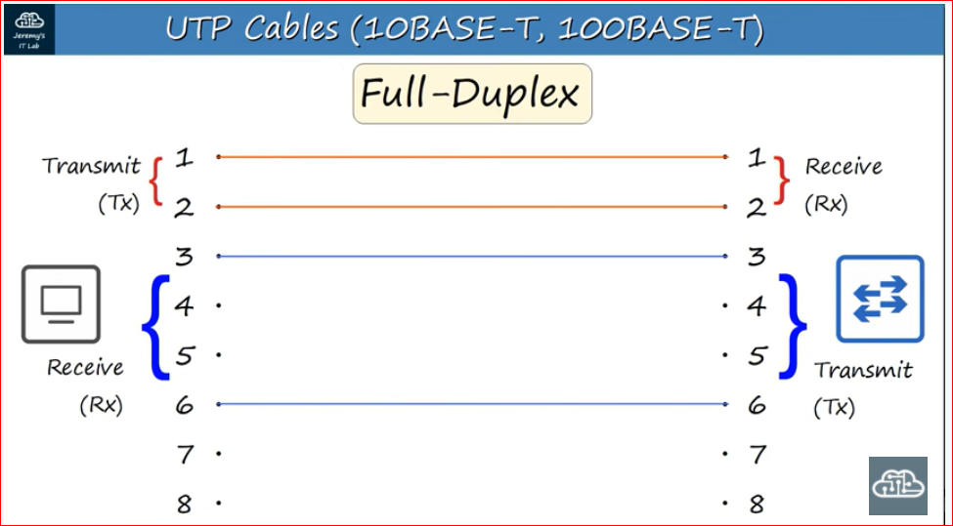

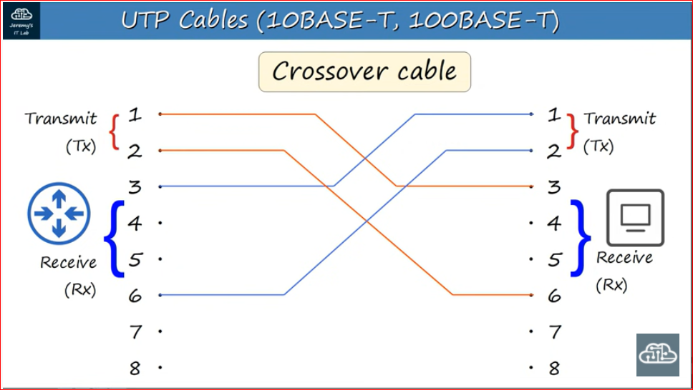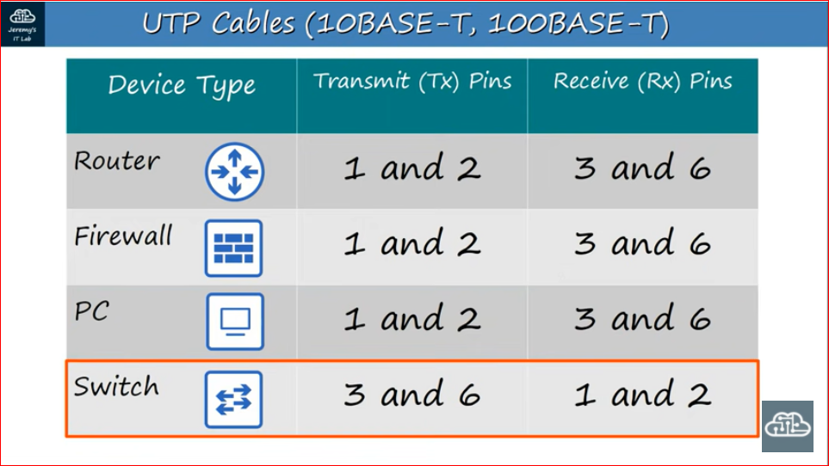

- RJ- Register jack. The ports where the Ethernet cables are being connected are known as RJ ports.
- Ethernet – Ethernets are the Ethernet cables to be jacked inside the ports. These are not only cables but these are cables with protocols. Which means the wires of the cables follows some rules in order to sends and receives data. Please look at the above diagrams for cable specifications.
- Industry Rules (IEEE Standard) –As to communicate to each other we much agree upon a common language let’s say English so that we understand each other, in the same way the data transfer all over the world must follow or agree upon a same rule in order to communicate. This rules are known as protocols (Network protocols). IEEE decides these protocol globally be that physical or hardware protocols such as UTP (Unshielded Twisted Pairs) cables or ip address respectively.
- Bit, Byte, Speed, Kilobit, Megabit, Gigabit, and Terabit: Computers only understands everything in the combination of 0s & 1s. Bits are representations of 0s & 1s. “0” is one bit, “00”/”01/”11”/”10” are two bits and so on. 8 bits makes one byte. 2 byte means 8X2=16 bits. The speed of the internet is represented as bits. Such as Kbps/Mbps (Kilobit per sec) /Megabits per sec).
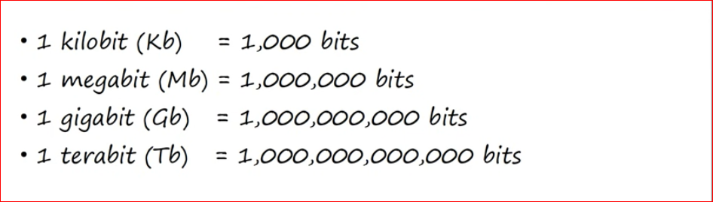
- UTP, Full duplex: Unshielded Twisted pairs. The Ethernet cables have coper wires where two wires are twisted together. There are total 4 pairs of twisted wires means total 8 single wires. They all are responsible for transmitting and receiving data. However depending on the types of UTP (10 mbps BASE-T, 100Mbps BASE-T etc.) it can either use 2 pairs or four pairs. It is a full duplex as data can be transmitted and received at the same time.
** Point to be noted for every devices (PC, Switch, and Router) the wires number for transmitting and receiving data might differ. (Check the above diagram).
- Straight Through Cable, Cross over cable - As a router/switch/PC will always have the dedicated number for wires for the data transmission or receiving that might create an issues if we want to transmit and receive data between two same device such as (PC-PC/Switch-Switch) etc. Such types of cables are known as Straight through Cable. However there are crossover cables where the data transmission and receiving will be done via different wires (check diagram).
- Auto MDI x : If a device has Auto MDI x then the number dedicated for the transmission and receiving isn’t an issue as it automatically assigns wires for transfer.

Chapter 3 (Video 5)
Keywords: Explain Internet, Cable/satellite internet, Browsers, Search engines, Websites, Web application, web server, Application server, Static content, Dynamic content, Web pages.
- Explain Internet: In simple words internet is a very complex connections with wires/cables, router, pc, modem, firewall and everything. Think about a highway with lots of connectivity of small roads, bridges, tunnel leading from one place to another place which is connected to high wat. Like that there are companies which connects big wires all over the world, then there are small companies (or internet service provider) like tire1, tire 2, tire 3. These small companies tire 3 connects to the big cables, tire 2 connects to tire 1,tire 3 connects to tire 2.We buy their services (Telecom, BSNL).Via a modem they send the data to us by wire or wireless connection.
Now there are two types of Internet available in the world DSL and Satellite. DSL is where we get internet via wires/cables. Satellite is where we get internet via signals. However, DSL is much cheaper and faster as of now but satellite internet are drastically improving. Satellite internet is good for remote areas or where DSL is not available.
- Web browser: Web browsers are NOT internet. It is a way to connect or get access to the internet. Web browser is simple a software application. Example-Firefox, Opera, Chrome. It allows us to access different websites via server. It sends the request to the server and fetch us information.
- Search Engine: Web browser and Search Engines are not the same. Web browser in an app while search engine is a website. Search engine is a website which search for another website given the key words. To open a search engine (website) we need web browser.
- Websites and web servers: A website is a collection of information (webpages).All these information is stored into a storage in a data center inside a hardware or cloud these storage are known as Server. Let’s say we want to access YouTube or a particular video in YouTube. We type the name of youtube.com or a keyword in web browser /search engine. Once we type it sends the request to the YouTube server asking to send the video we are looking for.
- The differences between Website and Web Application:
- The difference between Websites and Webpages
- The difference between webserver and application server.

Chapter 4
Keyword: OSI model, ip address, ports,

- Application layers work on software application level which means Google chrome, Firefox etc. Once you are on web browser and start browsing and website the application layer protocol starts working such as, find the ip address of the website we are trying to reach by DNS protocol, send request to the webserver using HTTP protocol and so on. So, the data from application layer should be send over the server/receiver. Before the data reach the destination it has to go through few more layer and in the process some extra information will be added. More broadly, after (Application+ Presentation+ Session=Data) it comes the transport layer, in this layer the data is already in 01 format. In transport layer the data is divided into chunks, the whole data is not sent over the internet due to the fact that it might get lost .If we send all data together that means if the data gets lost we will get no information. But if we send the data in chunks at least all data won’t be lost. This chunks are called segment in transport layer. Each segment has a header of port number of both sender and receiver, a sequence number. So that the data can be arranged in order before sending it to the endpoints. In the network layer some more information or header is added such as ip addresses for both destination and source. The Wi-Fi router works in this level. However, network layer also determine the best path for the packets to be send over the internet. Next datalink layer the here the Mac address it added with the packet and known as frame. In this part the bits are converted into electrical or optical signal and send over the physical layer such as optical cables.
